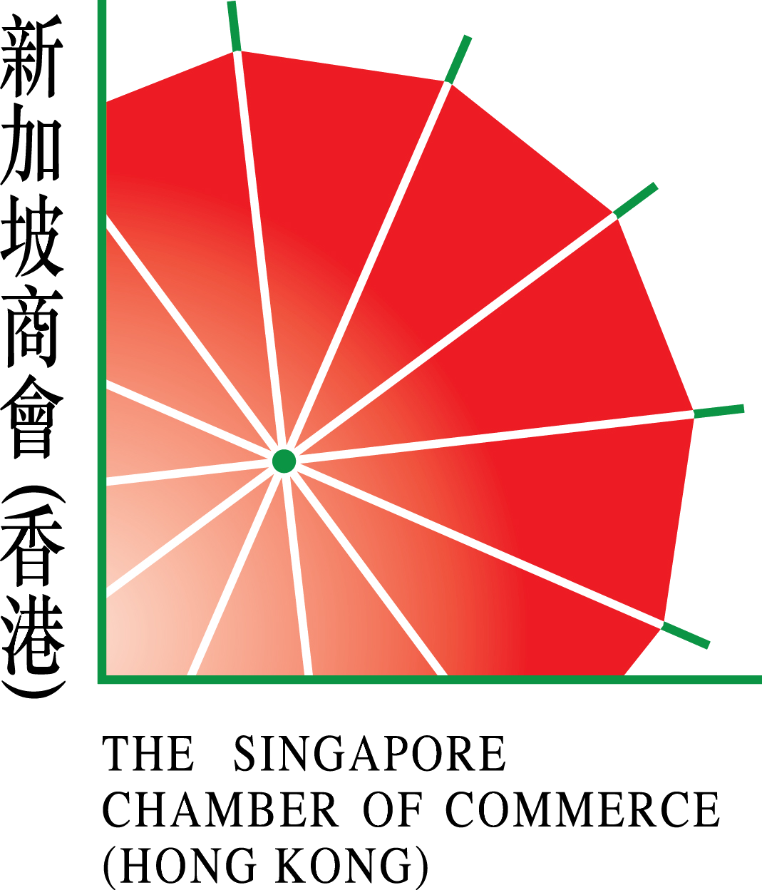

Incorporated with limited liability

R E P L Y S L I P
Please mail to:
The Singapore Chamber of Commerce (Hong Kong)
Unit 702, 7th Floor, China Hong Kong Tower, 8-12 Hennessy Road, Wanchai, Hong Kong

(A) □ I shall attend the AGM on Wednesday, 19th July 2023.
(Please return this Reply Slip by mail or email: scc@scchk.com.hk to the Chamber)

Name: _________________________ Signature: __________________

(B) □ I shall appoint a proxy to the AGM.
(Please return the below Proxy Form by mail or email: scc@scchk.com.hk to the Chamber)

P R O X Y F O R M

I/We, the undersigned of _____________________________(name of company) being an Individual Member/Member’s Representative of a Corporate Member of the Singapore Chamber of Commerce (Hong Kong) hereby appoint Mr./Ms./Mrs. ___________________________________ or the Chairman of the Chamber or failing him a Vice Chairman of the Chamber as my/our proxy to vote for me/us on my/our behalf at the 27th Annual General Meeting of the Chamber and at any adjournment thereof.

Dated this _____________ day of _______________ 2023.

________________________________________
Full Name of Member/Member’s Representative

________________________________________
Signature of Member/Member’s Representative

IMPORTANT: This Proxy Form must be duly completed and lodged with the Chamber
at least 48 hours before the AGM.

